

Rinnes Medical Group

Mount Street  Dufftown  AB55 4FJ  Tel: 01340 820888  Repeat Prescription Line Tel: 01340 821636  Website: www.rinnesmedicalgroup.co.uk | Rattray’s Lane  Tomintoul  AB37 9HF  Tel: 01340 820888  Fax: 01807 580419  Repeat Prescription Line Tel: 01340 821636

General Information
Rinnes Medical Group provides medical services to approximately 3000 people living in Dufftown, Tomintoul and the surrounding area. In addition, the doctors have a commitment to in-patient’s of the Stephen Hospital.

Contacting us
Telephone 01340 820888
Prescriptions 01340 821636
Health Visitor 01340 882107
District Nurse 01340 882108
Midwife 01343 567220

Opening Hours @ Dufftown Opening Hours @ Tomintoul
Mon 8:00 - 18:00pm 9:00 -12:30am 3:00 - 17:30pm
Tue 8:00 - 18:00pm 9:00 -12:30am
Wed 8:00 - 18:00pm 8:30 -12:30am 2:00 - 6:00pm
Thu 8:00 - 18:00pm 9:00 -12:30am
Fri 8:00 - 18:00pm 9:00 -12:30am 3:00 - 17:30pm

Extended Hours Sessions
Please see below for the service arrangements for our extended hours appointments. Please note you may not be able to see your usual doctor during these times. These are pre-bookable appointments designed for patients who would otherwise find it difficult to see a Doctor during normal opening hours due to their work etc.

Dufftown: Tuesday morning 07.30-08.00
Wednesday morning 07:30-08:00
Wednesday evening 18:00-18:30
Friday morning 07.30-08.00

Access
Patient areas in Rinnes Medical Group premises are suitable for wheelchair access and there is a designated Blue Badge holder’s parking space at the main door. For patients with hearing difficulties, there is a loop system at reception. We also have access to translation services for patients whose first language is not English. This booklet is also available in large print.

Registering with the Practice
Individuals and families living within the Practice Boundary can register with Rinnes Medical Group. You will be asked to complete a registration form for each individual wishing to register. Forms are available at the Practice or alternatively complete the Permanent Registration Form on our website.

If registering online, please also complete a New Patient Questionnaire.

If you are registering your baby, we require the form issued by the Registrar.

Once the registration process has been completed, you will be invited to attend a screening appointment with the nurse.

Temporary Registration
If you are ill while away from home and need to receive treatment for a medical condition, you can register as a temporary patient with a practice for up to 3 months. This will allow you to be on the practice list and still remain a patient of your usual GP. Simply contact a local practice for advice about this. Please be aware that you cannot register as a temporary patient anywhere within reasonable distance of your own practice, and that practices are not obliged to accept you on to their list although they do have an obligation to offer emergency treatment.
Temporary registration expires after 3 months, at which point you will have to reapply or register permanently with that practice.

Scottish Residents
If you have run out of medication whilst away from home and are registered with a Scottish GP practice, you can attend any community pharmacy who will be able to help you without the need to be seen by a GP.

UK Residents outwith Scotland
Please refer to our website for further information.

Changing Your Name or Address
Please ensure that we always have an up-to-date address and telephone number/mobile number for you at all times. You can update your details via the online form on our website, by telephoning the practice or filling in a form at the surgery.

Practice Team

Doctors
Rinnes Medical Group has one male GP and five female GPs working in a general partnership.

Dr Gaynor Graham (f) MBChB (Aberdeen) 2004 BSc (Med Sci), MRCGP, DFSRH, DRCOG
Dr Eilidh J O'Loughlin (f) MBChB 2005 Aberdeen, MRCGP, DFPSH
Dr Liam L O'Loughlin (m) MBChB 2005 Aberdeen, MRCGP (2012), PGCert SEM
Dr Catriona MacDonald (f) MBChB, MRCGP, MA (MedSci), BA (MedSci), DFSRH
Dr Lesley Willett (f) MBChB, MRCGP
Dr Mairi Crawford (f) MBBS, MRCGP, DRCOG, DFFP, DTM&H

Practice Nurse

Mrs Suzie McMillan

The Practice Nurse offers a large range of appointments at Dufftown and provides support for the GPs. Nurses are involved in blood tests, ECG’s, cervical screening, Dressings, Injections, healthy lifestyle, smoking and dietary advice. Suzie also assists with chronic disease management such as Asthma, COPD and Diabetes. You may be referred to the nurse by your doctor or you may make an appointment at reception.

Registered Nurse
Mrs Sarah Bennett
Mrs Fiona Thomson

Health Care Assistant
Miss Claire Meldrum

Practice Manager
Mrs Shirley French

The responsibilities of the practice manager include finance, the day-to-day organisation and management of the Practice, and quality issues. If you have any suggestions or queries, she will be happy to discuss these with you.

Assisting Practice Manager
Miss Marian Low

Administration Staff
Miss Jade Grant
Mrs Leanne Troup
Mr Ben McCourt
Mrs Beatrice Taylor
Mrs Myra Clive
Mrs Moira Foster (Tomintoul)

Our administrative team are the first point of contact with the practice. All staff are responsible for a wide range of duties including appointments and reception. Please help us to provide the best possible service by giving our administration staff all relevant information.

Pharmacy Team
Fiona Duncan, Pharmacist
Cameron Mackay, Pharmacist
Julie Bryce, Pharmacy Technician

Our practice pharmacists hold a clinic every Tuesday and Thursday morning and are happy to answer any medication queries you may have.

Community Nursing Team
District Nurses and Health Visitors work closely with the GP’s to provide a range of services to our patients.

Dawn Sugg, District Nurse Team Leader
Patricia Johnstone, Community Staff Nurse
Sharon Duncan, Community Staff Nurse
Barbara Low, Community Staff Nurse
Kelly Bowie, Community Staff Nurse
Diane Andrews, Health Care Assistant

The District Nursing team provide a service to the population of Speyside. They visit patients at home who are unable to attend the Health Centre, and provide support, advice and nursing care. For those patients who are terminally ill and wish to be cared for at home, the district nursing team do their utmost to meet their needs and care for both themselves and their carers.

The District Nursing team can be contacted by leaving a message on 01340 882108.

Health Visitor
Gail Howes RN HV
A health visitor is a registered nurse who has received training particularly related to babies, children and pregnant women. Their role is to provide families with children under five years old with support and advice around the general aspects of mental, physical and social wellbeing.
The Health Visitor can be contacted by leaving a message directly on 01340 882107.

Locum doctors
From time to time, locum doctors may be employed by the practice. They are fully qualified doctors with experience in general practice.

Teaching
We are a training practice and have a fully qualified doctor who works with us during the Registrar year in General Practice. On occasion the GP Registrar may wish to record your consultation on video.

Video Recording of Consultations
From time-to-time your doctor may wish to record patient consultations. Should he/she wish to do this, the receptionist will ask you to complete a consent form when you arrive for your appointment. The video consultation will not take place without your consent and should you wish to participate, please sign the consent form and return it to reception. You may change your mind at any stage and the camera must be switched off on request. Videos are used for training purposes and are only seen by the doctor.

Nursing students
The community and practice nursing teams support placements for nursing students from the Robert Gordon University. Student nurses may sit in with practice nurses or attend home visits with the community nurse or health visitor. We will always ask you when making an appointment or attending the surgery if you mind the student being present. Please tell us at any time if you would prefer not to do this.

Services

Appointments
Consultations with Doctors, Practice Nurses & Pharmacists are by appointment only. To make an appointment, please telephone the surgery on 01340 820888 or call in at reception. You may make an appointment to see any doctor or nurse. It is very important that you provide the reception Staff with as much information as possible regarding the nature of your symptoms in order that they can direct your need to the most appropriate Health Professional at the Practice. Our staff will make every effort to give you a convenient and early appointment, however you may have to wait a little longer for appointments at specific times e.g. after school or work.

Routine GP Appointments can also be booked online. Please see ‘Vision On-line Patient Services’ on our website on how to register for this service.

As a courtesy we send SMS text messages to mobile phones, reminding patients about their forthcoming appointments. It is important that you let us know as soon as possible if you cannot attend an appointment, so that we can offer it to another patient. On receipt of your SMS reminder, you can cancel by replying to the prompt. Please note that if you have chosen to Opt Out of this service, you will not receive these texts. You can also cancel appointments by calling us on 01340 820888 as soon as possible.

Urgent Appointment
If you feel you need to see your doctor urgently, please make this clear to our staff. The doctors will always respond to serious problems as soon as possible in the appropriate way whether by face to face appointment, telephone call, video call or home visit.

Home Visits
Whilst we encourage our patients to come to the surgery, where we have the proper equipment and facilities available, we do appreciate this is not always possible. In this respect, if you do need a home visit, you can help us by calling reception between 08:00–10:00. Please remember it may not always be possible to see your usual doctor.

You may only request a home visit if you are housebound or are too ill to visit the practice. Your GP will only visit you at home if they think that your medical condition requires it and will also decide how urgently a visit is needed. Please bear this in mind and be prepared to provide suitable details to enable the doctor to schedule house calls.

Out of Hours
Emergency cover during evenings, weekends and public holidays is provided by GMED and NHS24. If you require medical attention, please telephone 111 and you will be connected to NHS24. In an emergency, please dial 999

Emergencies - dial 999 and also phone your doctor
- heart attacks presenting as severe tightness or pain across the chest with sweating and breathlessness
- stroke
- collapse
- choking
- sudden severe bleeding
- accidents involving unconsciousness

We recommend that patients living in rural areas keep a note of their postcode or six- figure grid reference to assist the Scottish Ambulance Service in finding their address urgently. It would also be helpful to give instructions on accessing more remote addresses.

NHS24
You can contact NHS24 on 111 or www.nhs24.com

Repeat Prescriptions (Dufftown & Tomintoul)
If you require regular medication, a list of your repeat medication will be attached to your prescription. To order your medicines, please tick the box next to each item required and return the slip to the post-box at the main health centre door for Dufftown patients or Tomintoul surgery for Tomintoul patients. Alternatively you can order your medicines by phone – please telephone 01340 820888 and select Option 2 (24 hour answering machine) leaving a note of your name, address, date of birth and contact telephone number along with a list of the medication you require. Prescriptions can also be ordered by using our Vision Online Service. To register for this service, simply complete the online form on our website. This also enables you to book your own GP appointments.

Prescriptions are dispensed by Dufftown Pharmacy or you may ask to collect your prescription from the Health Centre reception. Tomintoul prescriptions are dispensed in the surgery and can be collected from the Tomintoul Surgery during opening times.

If you do not wish your prescriptions dispensed in Dufftown, please inform administrative staff of your Pharmacy of choice (ie. Rothes Pharmacy or Aberlour Pharmacy).

If you require your prescription to be posted back to you or forwarded to any other pharmacy, please provide a stamped addressed envelope.

Please allow three full working days for prescriptions to be processed and remember to take weekends and bank holidays into account.

Test Results
Our reception staff may where appropriate give out test results from your doctor. Please phone the health centre between 2pm and 5pm and select Option 4.

Telephoning your doctor
If you need to speak to your doctor, please telephone the receptionist. She will be able to advise you if your doctor is available and the best time to speak to him/her. Please telephone at 8:45 am if possible.

Telephone number withheld
We have increasing problems trying to contact patients who use a call barring system to block calls from withheld numbers. For confidentiality, the health centre and doctors’ mobile telephone numbers are withheld. If you use call barring on your telephone line, we may be unable to contact you by telephone.

Public Holidays
Rinnes Medical Group will be closed during NHS Grampian public holidays. Details will be posted throughout the Health Centres, Dufftown Pharmacy, our practice website and on our Facebook page.

General Medical Services
Rinnes Medical Group provide the following services:

- care for patients who are ill or believe themselves to be ill
- care for terminally ill patients
- management of chronic disease including asthma, chronic obstructive pulmonary disease, diabetes, stroke, coronary heart disease, epilepsy, mental illness, cancer, hypertension, hypothyroidism
- cervical screening
- contraceptive services
- child health surveillance
- maternity services
- minor surgery
- minor injury
- monitoring of patients on Warfarin or disease modifying drugs

Asthma
All asthma patients are reviewed regularly by the nurse/doctor.

Child Health
The Health Visitor is available to advise and support parents with their children’s progress and will regularly review children’s health and development until school age. They are available for advice and it is an opportunity to discuss any childcare or parenting issues and weigh children if required.

Child Immunisation
Baby immunisations are carried out by the Immunisation Nurse or Health Visitor. Pre-school immunisations are given to children between four and five years of age.

Chronic Diseases
Management of chronic diseases include asthma, chronic obstructive pulmonary disease, diabetes, stroke, chronic heart disease, epilepsy, mental illness, cancer, essential hypertension, hypothyroidism. Patients will be called on their birth month for annual monitoring with the healthcare assistant/practice nurse.

Contraception
All doctors provide family planning services during routine consulting hours. You need to see your doctor for review every year.

Counselling
This is available following referral from your doctor.

Developmental Assessment
Children are seen on an appointment basis by the GP/Health Visitor for developmental and physical checks. This can include a top to toe physical examination, a hearing test and developmental review.

Diabetes
The practice runs a diabetic clinic at Dufftown. Patients are seen at 6 month and 12 month intervals by the practice nurse/healthcare assistant and GP.

Diabetic Retinal Screening

This screening test is offered to people aged 12 and over with Type 1 or Type 2 diabetes. Retinal screening clinics are held at Rinnes Medical Group.

Flu Vaccination

In 2017, the Scottish Government and the Scottish General Practitioners Committee (SGPC) agreed vaccinations would move away from a model based on GP delivery to one based on NHS Board/Health and Social Care Partnership (HSCP) delivery through dedicated teams.

The NHS Grampian Health Protection Team is now responsible for the implementation of the annual seasonal flu vaccine and all other vaccines for health protection.

Frailty & Dementia

NHS Grampian Frailty & Dementia nurse visits the practice every Monday to help and support anyone living with frailty and/or dementia.

HGV Medicals
HGV medicals are arranged on an appointment basis. This service is offered outwith the NHS and a fee is payable.

Hormone Replacement Therapy

Patients taking HRT are reviewed every 6 months.

Medical Certificates (Med 3)
You do not require a Doctor’s sick note for any illness lasting 7 days or less. This is covered by a self-certification form (SC2), which is available from your employer or on the HMRC website.

If you are sick for more than 7 days, your employer can ask you to give them some form of medical evidence to support payment of SSP (statutory sick pay). This is known as a ‘Statement of Fitness for Work’ (sick note/Med 3) issued by a medical practitioner. This may require a telephone or face to face appointment. Practice staff will be able to advise you.

Conditions which are ongoing may be requested via administrative staff, and a message will be sent to the registered GP to review the request.

Fitness or a return to work certificate is not normally issued.

Mental Health
The mental health team hold clinics in the Health Centre, Dufftown on a weekly basis and periodically in Tomintoul.

Minor Surgery
All of the doctors offer minor surgery. Please discuss this with your doctor.

New Patient Health Screening
All patients registering with Rinnes Medical Group are invited to attend a screening appointment with the nurse.

Podiatry
Appointments are arranged following referral from your doctor or nurse.

First Contact Physiotherapy
Our FCP has a clinic at the Practice on a Thursday morning.

Warfarin
Patients taking Warfarin are monitored by their GP. Appointments for warfarin blood tests are made with either the practice nurse or HCA.

Pharmacy First
NHS Pharmacy First Scotland allow community pharmacies to give people expert help for treating conditions such as sore throats, earache and cold sores, along with common clinical conditions such as urinary tract infections (UTI’s). Pharmacy teams offer advice, treatment or referral to other healthcare teams if required.
This service will help people access the right care in the right place, without having to go to their GP practice or local Accident and Emergency Department for non-urgent treatment.
Examples of general conditions that can be dealt with by NHS Pharmacy First:
- Acne
- Allergies (including Hayfever)
- Athletes Foot
- Bacterial Conjunctivitis
- Cystitis (UTI)
- Dry Eyes
- Earache
- Haemorrhoids (piles)
- Hayfever
- Impetigo
- Mouth Ulcers
- Shingles
- Skin Conditions
- Skin Infections
- Sore Throat
- Thrush (vaginal)
- Thrush (oral)
- Warts & Verrucae

Suggestions and Complaints
We welcome any suggestions or comments you may have on our service.

If you have a complaint or concern about the service you have received from the doctors or any of the staff working in the Health Centre, please let us know. We operate a practice complaints procedure as part of the NHS system for dealing with complaints, and can provide you with a leaflet outlining the process. Complaints should be addressed in the first instance to Mrs Shirley French, Practice Manager.

Alternatively, you may telephone or ask for an appointment with the Practice Manager in order to discuss your concerns.

We shall acknowledge your complaint within 3 working days and aim to have looked into your complaint within 10 working days of the date when you raised it with us.

We hope to be able to address your concerns and provide you with an explanation. This does not in any way affect your right to make an independent complaint to the NHS Complaints Team, St Martins House, 181 Union Street, Aberdeen, AB11 6BB if you so wish.

If you remain dissatisfied with the outcome of your complaint, you have the option of contacting the Scottish Public Ombudsman (SPSO).The SPSO cannot normally look at:

- A complaint that has not completed our complaints procedure
- Events that happened, or that you became aware of, more than 12 months ago
- A matter that has been or is being considered in court.

The SPSO’s contact details are:

Scottish Public Service Ombudsman or Freephone: 0800 377 7330
Bridgeside House, Online contact: www.spso.org.uk/contact-us
99 McDonald Road Website: www.spso.org.uk
EDINBURGH EH7 4NS

If you need help with your complaint, you should contact:

Circles Advocacy Moray or Moray Citizens Advice Bureau
40-42 Moss Street 6 Moss Street
Elgin Elgin IV30 1LU
IV30 1LT 01343 550088
01343 559646

Charter of Patient Rights
- We aim to provide the best possible service to all our patients.
- You have the right to safe, effective, person-centred and sustainable care and treatment that is provided at the right time, in the right place, and by the most appropriate person
- We respect the confidentiality and privacy of individual patients and provide open access to information on services and treatment.
- You are entitled to information and practical help towards healthier living.
- You have the right to be treated fairly and equally and will not be discriminated against whatever your health needs and wherever you live in Scotland.
- People have a right to expect honesty, respect and the preservation of their dignity.
- You are entitled to access, with safeguards, to information held about you by the NHS; and to be sure that this information will be kept confidential. You also have a right of access to medical reports made for insurance or employment purposes. All personal records in the NHS are confidential and all persons in the Service must abide by the code of practice on confidentiality or personal health information.
- You are entitled to be involved so far as is practical in making decisions about your own care, and wherever possible, given choices including choice of GP, the right to give or withhold consent to medical treatment, the right to decide whether or not to participate in medical research and student training.

Charter of Patient Responsibilities
- You should share in the responsibility for your own health.
- Care for yourself when appropriate (for example you can treat yourself at home for common ailments such as coughs, colds and sore throats).
- Keep your appointment or let us know as soon as possible if you cannot keep it. Book routine appointments in plenty of time. Help us by turning up on time and with everything you need.
- Give notice if you change your address.
- Return any equipment no longer needed.
- Treat NHS staff, fellow patients, carers and visitors politely and with respect.

Violent, Aggressive or Abusive Behaviour
Patients and staff in the health centre have a right to be treated politely and with respect. Violent, aggressive or abusive behaviour towards patients or staff is completely unacceptable and will not be tolerated under any circumstances. Any behaviour which compromises the safety of patients or staff will be reported immediately to the police. Such behaviour can result in removal from the practice list.

Data Protection
Your records are held on our computer system. Rinnes Medical Group is registered under the Data Protection Act. Your medical record is kept secure by the practice and only those professionals who are directly involved in your care have access to your record e.g. your doctor, nurse, practice pharmacist. Other persons may only have access to your record with your written permission e.g. solicitors, insurance companies.

We place paramount importance on service and aim to meet your expectations on every occasion to provide you with health care and treatment. To achieve this we need accurate personal information from you, which we review regularly, to ensure we take into account any changes in your circumstances. We have a legal obligation under the Data Protection Act to ensure that all information held and processed about you complies with the principles of the Act. We keep your information for other reasons; for example, to help us protect public health generally and to see that the Health Service runs efficiently, plans for the future, trains its staff and can account for its actions. Information may also be needed to help carry out medical or other health research for the benefit of everyone.

Sometimes the law requires us to pass on information: for example, to notify of a birth. Everyone working for the Health Service has a legal duty to keep information held about you confidential. You may be receiving care from other health-care professionals as well as your GP. So that we can all work together for your benefit we may need to share some information about you. We only ever use or pass on information about you if people have a genuine need for it in your and everyone’s interests. Whenever we can we shall remove details which identify you. The sharing of some types of very sensitive personal information is strictly controlled by law. Anyone who receives information from us is also under a legal duty to keep it confidential.

The main reasons for which your information may be needed are:-

- providing you with health care and treatment
- looking after the health and social welfare of the general public
- ensuring our services can meet patient needs in the future
- helping staff to review the care they provide, thus ensuring that it is of the highest standard
- training and educating staff (you may choose whether or not you wish to be involved personally)
- investigating complaints or legal claims
- statistical analysis and research (you will not be identified in any published results or papers without your prior consent)
- preparing statistics on performance and activity (steps shall be taken to ensure that you cannot be identified)

If at any time you would like to know more about how we use your information, you can speak to the Practice Manager or alternatively you may obtain a copy of the information we hold about you by making a Subject Access Request. There may be a fee for this service. Applications for Subject Access can be made by contacting the Health Centre.

Freedom of Information Scotland Act 2002
Our general practice has formally adopted the British Medical Association model publication scheme for general practitioners in Scotland and for all enquiries relating to practice information which is contained in this scheme please contact the Practice Manager.

Practice Area
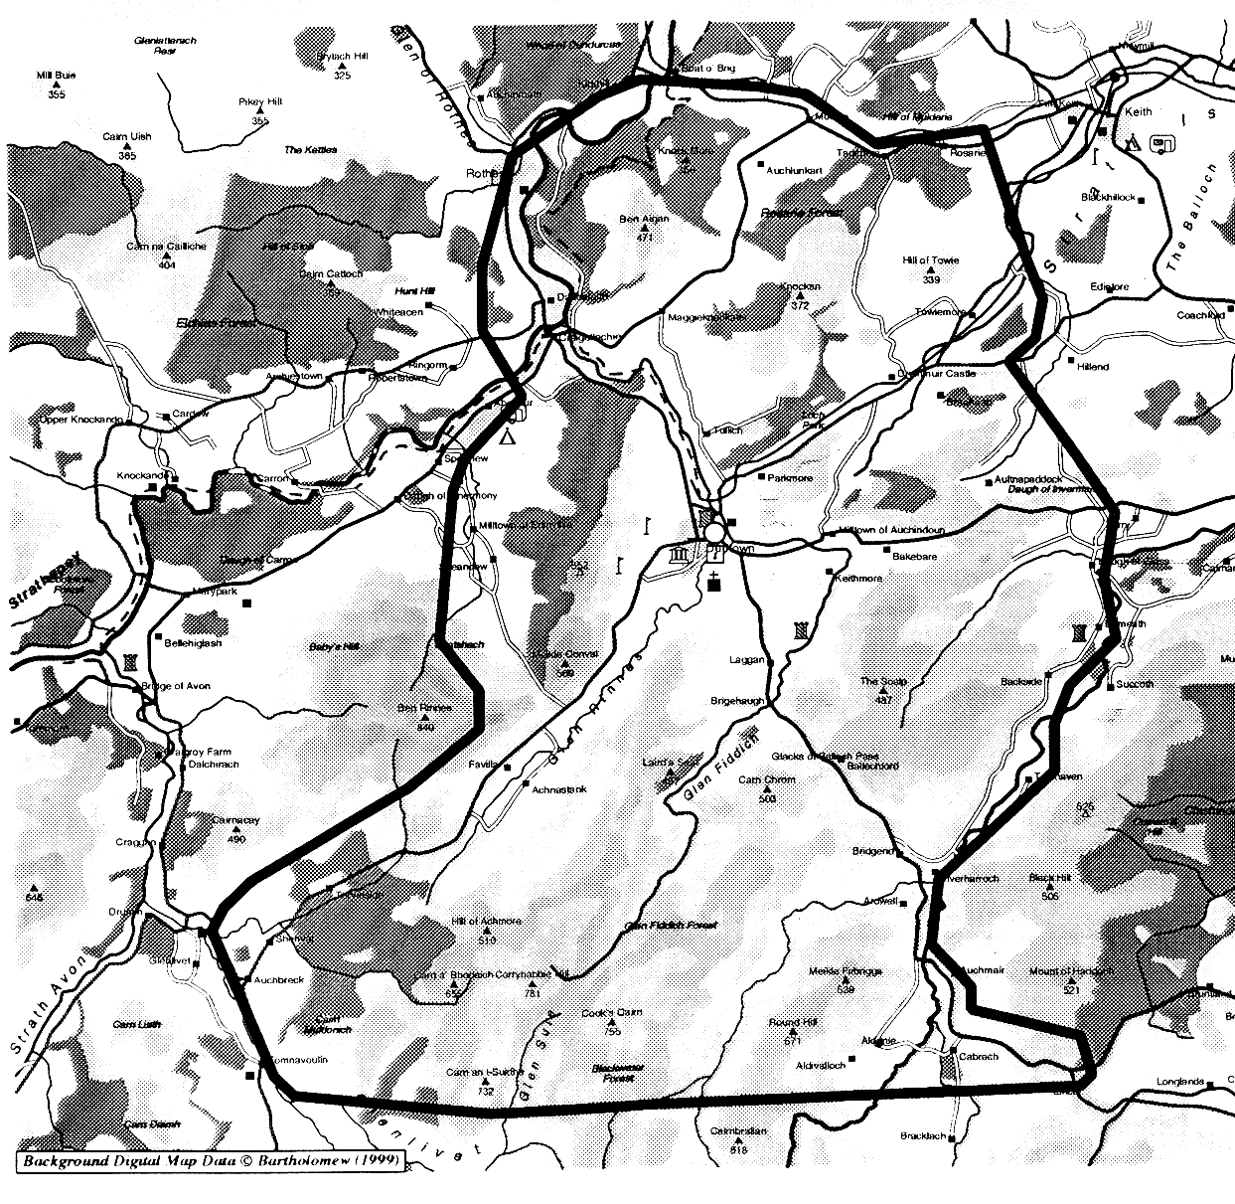

Useful Addresses
www.patient.co.uk
www.bbc.co.uk.health
www.hebs.co.uk
www.show.scot.nhs.uk

NHS Grampian
Summerfield House
2 Eday Road
Aberdeen AB15 6RE
Tel 01224 558565

